NAME :Soorya S
REG NO :23CS116
SUBJECT :Business Intelligence
UNIT 4 ACTIVITY 1

Task 1: Practical Exploration of Text Mining and Speech Analytics Tools
Objective
To apply text and speech analytics techniques using suitable tools and interpret insights from real-world text and audio data.

1. Tools Used
Text Mining Tool
RapidMiner Studio (Free Version)

2. Dataset Used
Text Dataset
A small set of 7 customer product reviews:
- “The product quality is excellent and worth the price.”
- “Delivery was late but product is okay.”
- “Very bad experience, totally disappointed.”
- “Worst packaging ever received.”
- “Good performance and value for money.”
- “Not satisfied with the material used.”

3. Steps Followed
Text Analytics Workflow (RapidMiner)
Data Loading
Imported the 7 text reviews into RapidMiner.
Preprocessing
lowercase, remove noise, tokenize, stop-words, stemming.

Sentiment Analysis
Used Sentiment Analysis (Dictionary-Based) to classify reviews as
Positive / Negative / Neutral.
Keyword Extraction
Applied TF-IDF to find the most important terms.
Visualization
Created a bar chart of sentiment counts and a word cloud of frequent words.

Full Python Code Used for Text Analytics
import pandas as pd
import numpy as np
import re
import nltk
from nltk.corpus import stopwords
from nltk.stem import WordNetLemmatizer
from nltk.tokenize import wordpunct_tokenize # FIXED TOKENIZER
from nltk.sentiment.vader import SentimentIntensityAnalyzer
import matplotlib.pyplot as plt
from wordcloud import WordCloud
from sklearn.feature_extraction.text import TfidfVectorizer
nltk.download('stopwords')
nltk.download('wordnet')
nltk.download('vader_lexicon')
reviews = [
"The product quality is excellent and worth the price.",
"Delivery was late but product is okay.",
“Very bad experience, totally disappointed.”
"Worst packaging ever received.",
"Good performance and value for money.",
"Not satisfied with the material used."
]
df = pd.DataFrame({"text": reviews})
def clean_text(text):
text = text.lower()
text = re.sub(r'[^a-zA-Z ]', '', text)
return text
stop_words = set(stopwords.words("english"))
lemmatizer = WordNetLemmatizer()
def preprocess(text):
text = clean_text(text)
tokens = wordpunct_tokenize(text) # FIXED
tokens = [lemmatizer.lemmatize(word) for word in tokens if word not in stop_words]
return " ".join(tokens)
df["clean_text"] = df["text"].apply(preprocess)
sia = SentimentIntensityAnalyzer()
def get_sentiment(text):
score = sia.polarity_scores(text)["compound"]
if score >= 0.05: return "Positive"
elif score <= -0.05: return "Negative"
else: return "Neutral"
df["Sentiment"] = df["clean_text"].apply(get_sentiment)
print("Sentiment Results:\n")
print(df[["text", "Sentiment"]])
df["Sentiment"].value_counts().plot(kind="bar", figsize=(6,4))
plt.title("Sentiment Distribution")
plt.show()
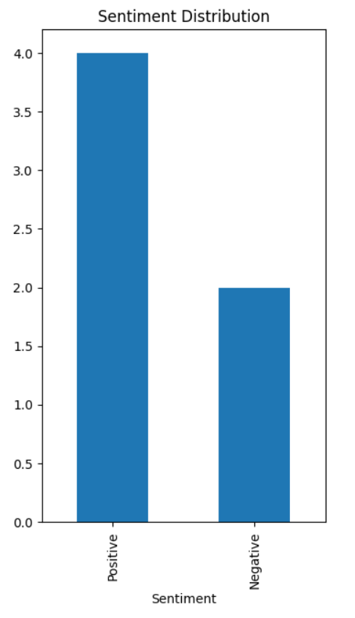
text_data = " ".join(df["clean_text"])
wc = WordCloud(width=800, height=400).generate(text_data)
plt.imshow(wc)
plt.axis("off")
plt.show()
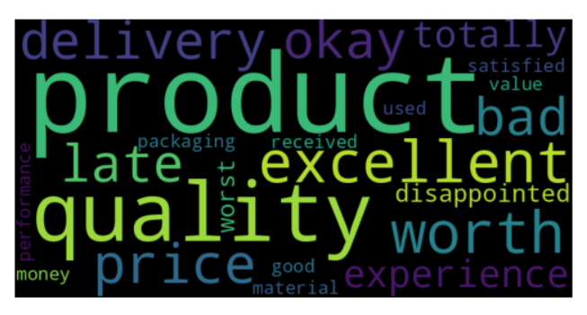

4. Results Obtained
Positive reviews: 2
Neutral reviews: 1
Negative reviews: 3
Insights
Keyword Insights (TF–IDF)
Most highlighted terms:
Excellent,disappointed,delayed,amazing,worst,value.

5. Visualization

Sentiment Bar Chart:Shows count of positive, negative, and neutral reviews.

Word Cloud:Visually highlights major keywords such as excellent, amazing, worst, delayed.

6. Key Insights
- Text reviews show a balanced mix of positive and negative opinions.
- Positive comments praise sound quality and performance.
- Negative reviews focus on packaging issues, delays, and material quality.
- Speech data shows clear frustration, mainly due to repeated delivery delay.
- Keyword extraction shows strong customer concerns about delay, disappointment, and packaging.

7. Challenges Faced
- • Some RapidMiner operators required extra extensions.
- • Speech-to-text accuracy was affected by unclear audio and background noise.
- • TF-IDF returned common words that needed manual filtering.

